**GRAPHS**

**RL CIRCUIT**



**RLC CIRCUIT**





**COMPLEX RLC CIRCUIT**



**SIMULINK MODELS**

**RL CIRCUIT**

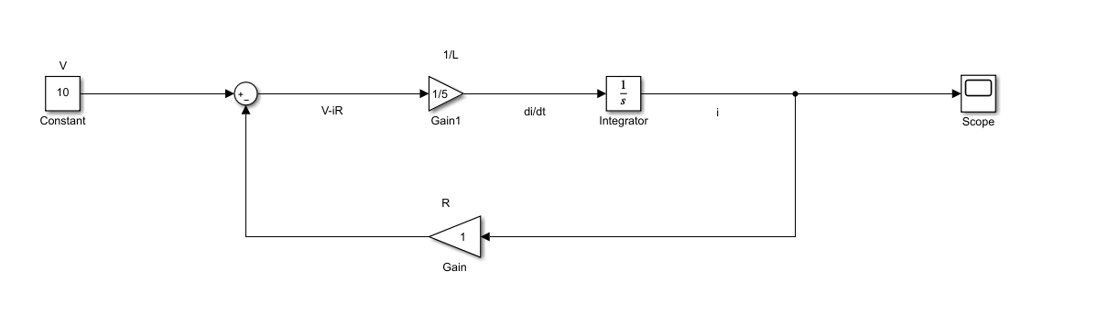

**RLC CIRCUIT**

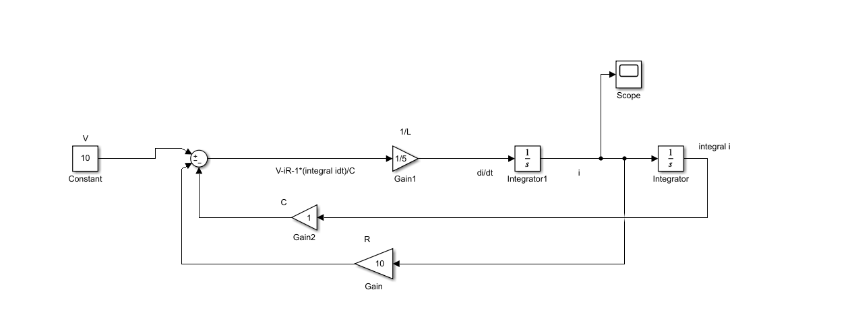

**COMPLEX RLC CIRCUIT**

